Instruction’s for Completing the CEI Foundation Scholarship Application:
Step 1: Sign In:
Go to https://CEI.elluciancrmrecruit.com/Apply to complete the CEI Foundation Scholarship Application. If you have never signed into the Apply Now portal before, you will need to create a new account. Even current students with an assigned CEI Email, will need to create a new account if they have never logged into the Apply Now portal. You may use your CEI Email and login credentials to create the account.
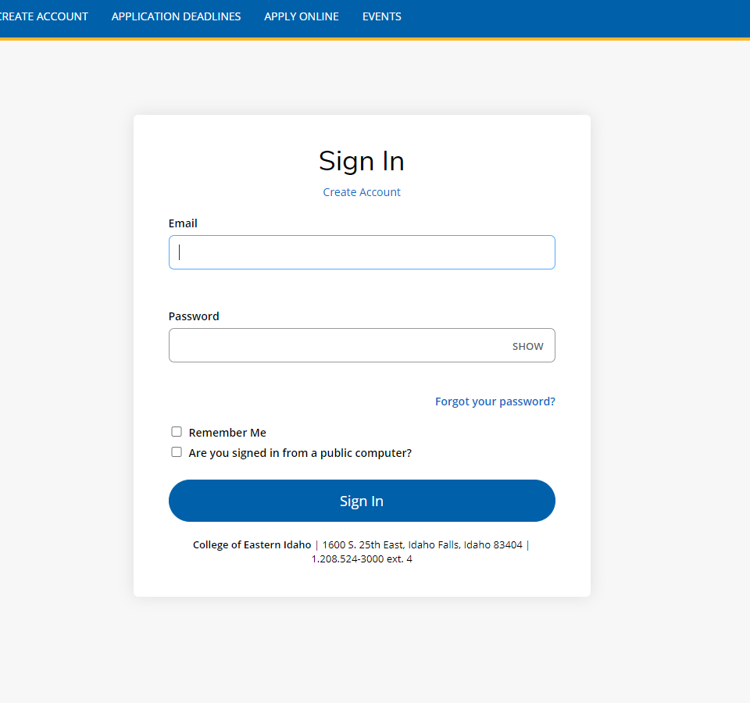

Step 2: Create an account:
Please fill out all the required fields (indicated by the red asterisk *). New students will create the account using the information pertaining to their expected date of enrollment.
Current students, already attending classes at CEI, please select the Fall 2021 term for “Anticipated Entry Term” field.
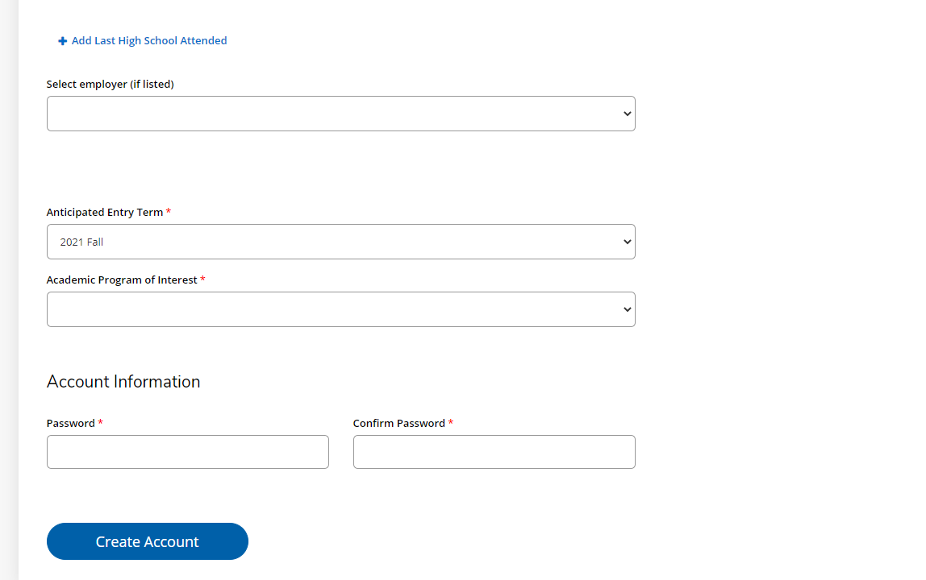
Step 3: Create a New Application:
Please select “Create a New Application” which will then allow you to select “Start New Scholarship Application”.
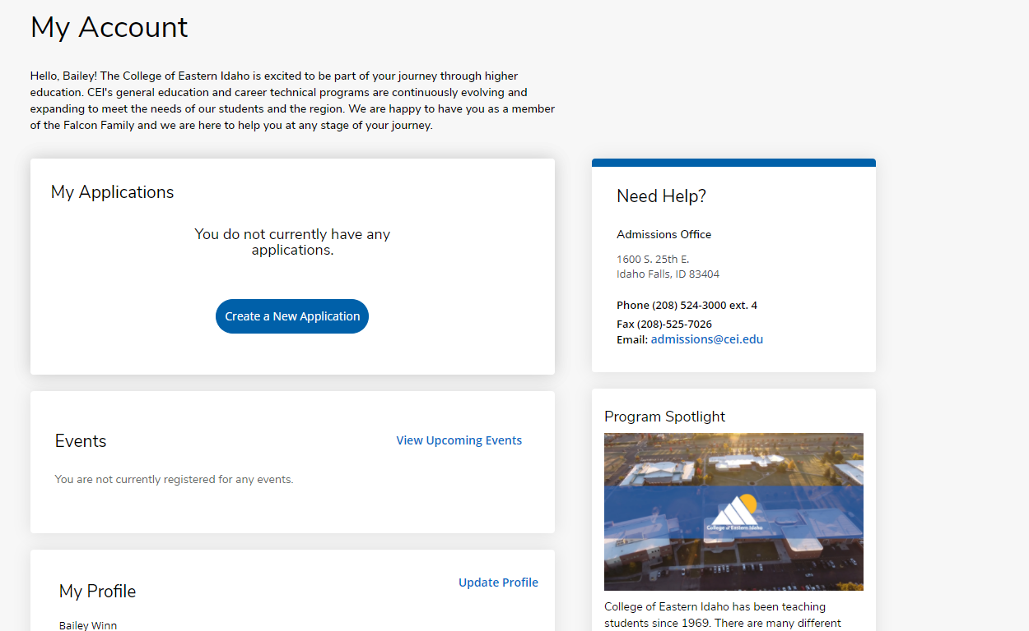
Start a NEW SCHOLARSHIP APPLICATION:
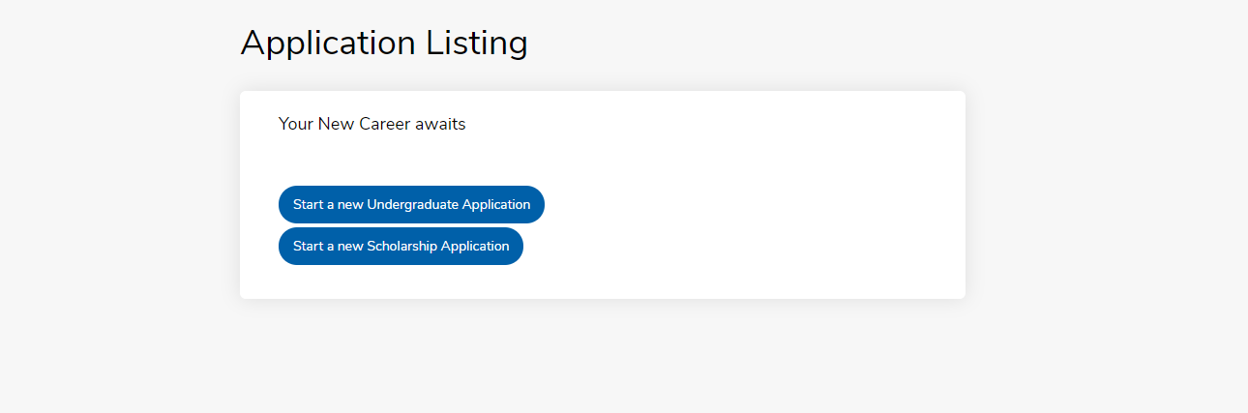

Step 4: Complete the Application Questions/Information and Submit Supplementary Items:
Please fill out and complete the application to the best of your knowledge with the most current information. Once you have finished answering all the question fields and agreed to the clarifying statements, you will be taken to the page where your application is available to view (see image).
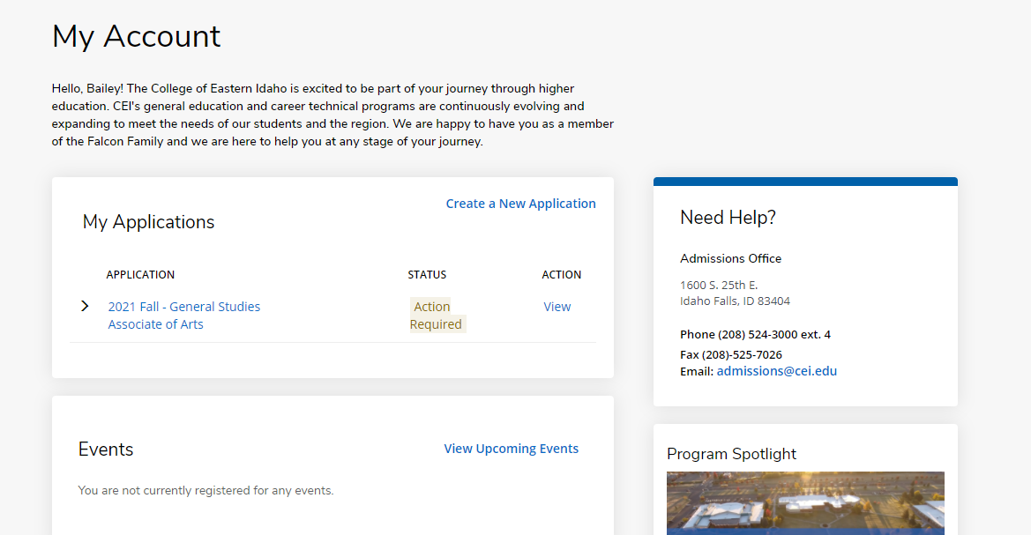

Here students will be able to view the status of their application and submit their supplementary items (Personal Essay and Letter of Recommendation) required to complete their CEI Foundation Scholarship Application. Students will be able to either upload a letter of recommendation themselves, or request one through email using the “Recommendation Request” feature.
STUDENTS WILL NOT NEED TO UPLOAD THEIR TRANSCRIPT IN ORDER TO COMPLETE THEIR SCHOLARSHIP APPLICATION, EVEN IF IT SHOWS AS AN ACTION ITEM. Transcripts are only required to complete your Admission Application (see image below).
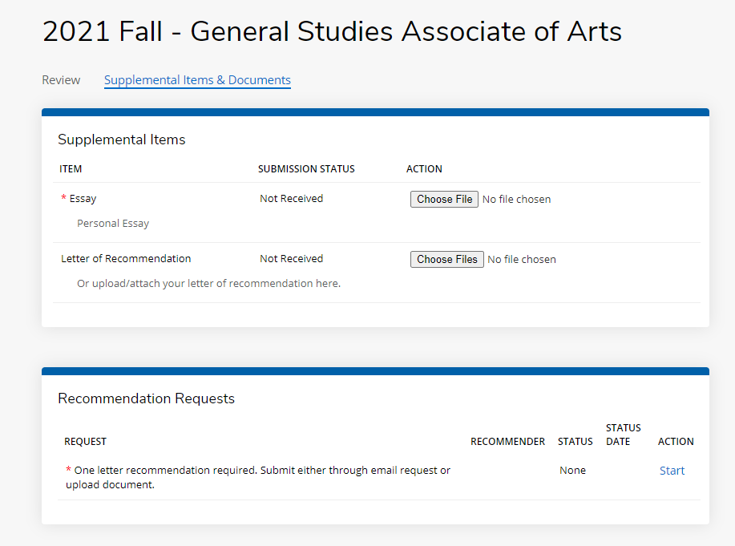
Students will receive emails from the application portal on their application status anytime they update their application or complete/submit the required items. Please pay attention to these emails as they will have important communications and deadlines for students.

