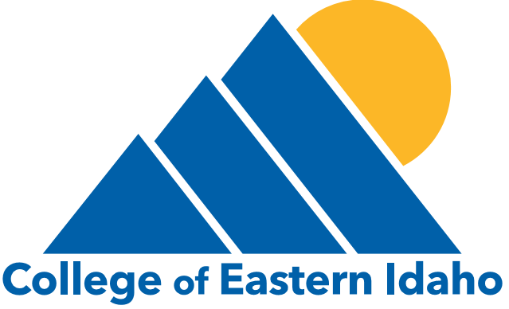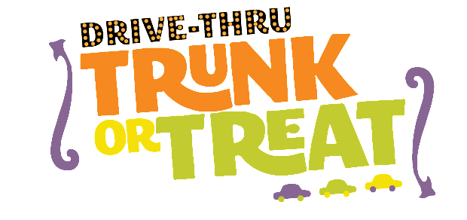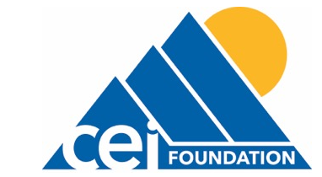
1600 S. 2500 E. | IDAHO FALLS, IDAHO 83404 | (208) 524-3000
________________________________________________________________________________________________________
DRIVE THRU TRUNK-OR-TREAT
October 28, 2021 • 5-8 p.m. | College of Eastern Idaho

College of Eastern Idaho, CEI Foundation and the CEI Student Senate will be hosting a free community Drive Thru Trunk-or-Treat event on the CEI campus. This year we are one of the only Trunk or Treat Events in the area! Trunk space is limited so turn in your registration form as soon as possible!

We would love to have your organization participate! We would sincerely appreciate donations of candy or to have your company participate in the event by decorating a car or truck “trunk” and passing out candy to children in attendance. 100% of your donation is tax-deductible!

All cars and trucks are welcome and must complete the attached form prior to the event. Vehicle owners are urged to come in costume.

RULES OF TRUNK PARTICIPATION
• College of Eastern Idaho will provide some candy to be given out at the trunks, but participants must bring 1,000 pieces of additional candy to distribute. Participants may pay $150 in addition to the register fee and all candy will be provided. Sponsorships Available – See Below
• Trunks are required to have a minimum of 2 candy distributors but are recommended to have at least 4. Candy will be handed out on both sides of the drive-thru line.
• Please be courteous to your trunk neighbors and keep your music volume and your decorations confined to your booth space.
• In order to run an efficient event please limit your booth space to passing out candy. Campaigning, games, photo booths, or other activities will not be allowed. For safety reasons the public will not be allowed to leave their vehicles. If you have questions about ideas for your trunk space please call Bailey Winn at (208) 520-4622. We will be happy to do our best to accommodate your company’s ideas.
• Registered vehicles must arrive at the North parking lot (at the light off Hitt Rd by Walmart) on the College of Eastern Idaho campus between 3 and 4:30 p.m. Vehicles that show up after 4:30 p.m. will not be able to participate and will forfeit their registration fee. All registered vehicles must be prepared to stay until the event ends after 8 p.m. For safety purposes, vehicles will not be permitted to move or leave the parking lot until all children have left the parking lot.
• No selling of products, merchandise or services is permitted. You may distribute coupons and certificates along with candy.
• We will not be able to provide any electrical support for your vehicle decorations.
• Deadline for entry is 5 p.m., Friday, October 22, 2021. Please return the below form with your $75 entry fee to: CEI – Trunk-or-Treat, 1600 S. 2500 E., Idaho Falls, Idaho 83404 OR scan form to bailey.winn@cei.edu. You can also register and pay online visit www.ceigiving.org and click on the Trunk or Treat tab.
CANDY DONATIONS / MONETARY DONATIONS
•We would appreciate any donations of individually-wrapped candies or gift-cards to purchase candy. Please make checks payable to CEI Foundation.

Trunk or Treat 2021 Sponsorship
All funds raised in Registration and Sponsorships fees are utilized to purchase candy for the event.
Any proceeds help fund the scholarship programs at the College of Eastern Idaho facilitated by the College of Eastern Idaho Foundation.
THE GREAT PUMPKIN KINGS - $1,000 – 2 Available
- Large print main sponsor center logo on event banner
- Sponsored by logo on all posters and marketing material including 10 social media posts
- Thank you mention at the event as main sponsor on our private radio station
- First car placement in Trunk or Treat line (candy will be handed out on both sides of the vehicle)
- Ability to hand out marketing material or provide bags
- Registration and candy covered for the entire event
THE DARING DRACULAS - $750 – 2 Available
- Medium print logo on banner
- Sponsored by logo on all posters and marketing material including 8 social media posts
- Thank you mention at the event as sponsor
- Front of the line car placement in the Trunk or Treat Line
- Ability to hand out marketing material
- Registration and 750 pieces of candy covered for the event fee
(sponsor will need to purchase 250 pieces for entrance)
THE FRIENDLY FRANKENSTEINS - $500 – 4 Available
- Small print logo on banner
- Supported by logo on all posters and marketing material including 6 social media posts
- Thank you mention at the event as supporter
- Ability to hand out marketing material
- Registration and 500 pieces of candy covered for the event fee
(sponsor will need to purchase 500 pieces for entrance)
TRUNK OR TREAT REGISTRATION FORM
Business or Campus Club Name___________________________________________________________________________
Name/Theme of Trunk ___________________________________________________________________________
Contact Person ___________________________________________________________________________________________
Mailing Address___________________________________________________________________________________________
City _________________________________________________________ State ____________ ZIP_______________________
Phone (____) ________________ Email ________________________________________________________________________
Form of Payment: Cash Check Online
Name on Credit Card for Online Payment________________________________________________________
Trunk Only Donation Only Sponsorship _______________________ Level
* * * * * * * * * * * * * * *
TRUNK OR TREAT ASSUMPTION OF RISK, WAIVER AND IMAGE RELEASE FORM
I acknowledge that my participation in this event could involve risk of physical injury or damage to property. I expressly assume such risk and release and waive any claims against the State of Idaho, College of Eastern Idaho, College of Eastern Idaho Foundation, its agents and employees, for any injuries to persons or damage to property, whether the result of negligence, breach of warranty or otherwise. I further agree to hold the State of Idaho, College of Eastern Idaho, College of Eastern Idaho Foundation, its agents and employees, harmless for any injury to persons or property damage caused by involvement in this activity. This Assumption, Waiver and Image Release form is effective and binding. I have read and understand this Assumption, Waiver and Image Release form.
I also authorize use of my name and picture to be released for use in event coverage and promotion future events.
Signature: __________________________________________________________________ Date____________________

CEI Foundation – www.ceigiving.org E-mail completed forms to: bailey.winn@cei.edu

